**8218-Arsh Nadeem-AWS Introduction-Jan-2025**

2.Host a static website in S3.

**Creating an S3 Bucket**

In aws free tier account search for the s3

Create a New Bucket

* + Click on "Create bucket".
  + Enter a unique Bucket name (e.g., arsh-static-website).
  + Choose the AWS Region closest to your target audience.
  + Keep the "Block all public access” option unchecked .
  + Confirm the acknowledgment to allow public access and click Create bucket.

### **Upload Your Website Files**

Opening the bucket

Click on newly created bucket

Upload Files

* + Click on "Upload", then "Add files".
  + Selecting your static website files (e.g., index.html, styles.css, images, etc.).
  + Click Upload to upload your files to the bucket.

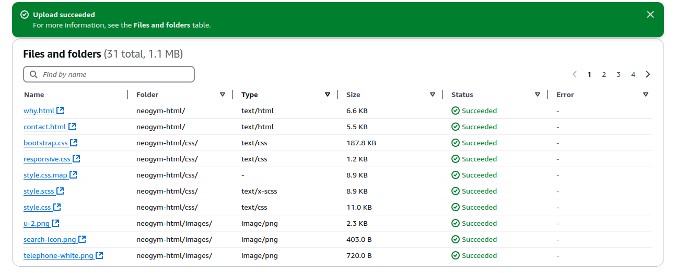

### **Making Your Bucket Public**

1. **Enabling Public Access**
   * Go to the Permissions tab of your bucket.
   * Under BucketPolicy, click Edit.
2. **Set Bucket Policy**
   * Pasting the following policy to make your bucket public:

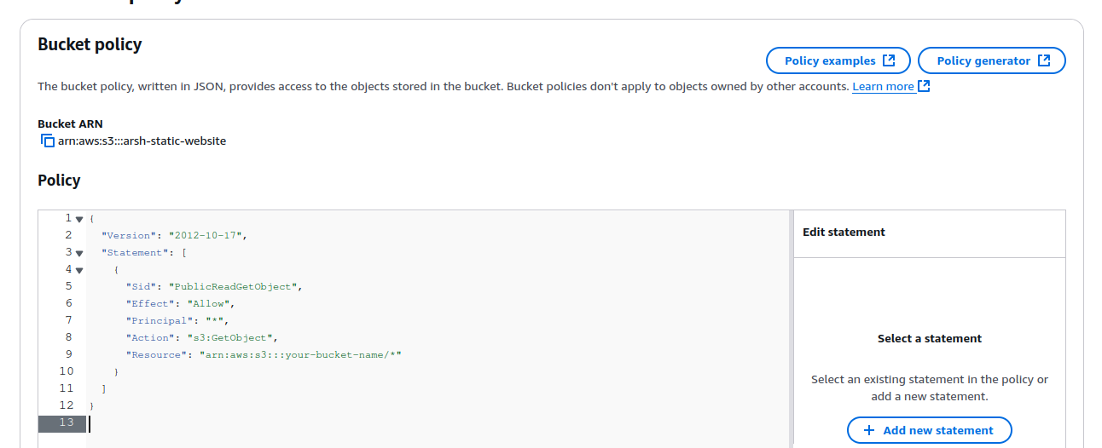

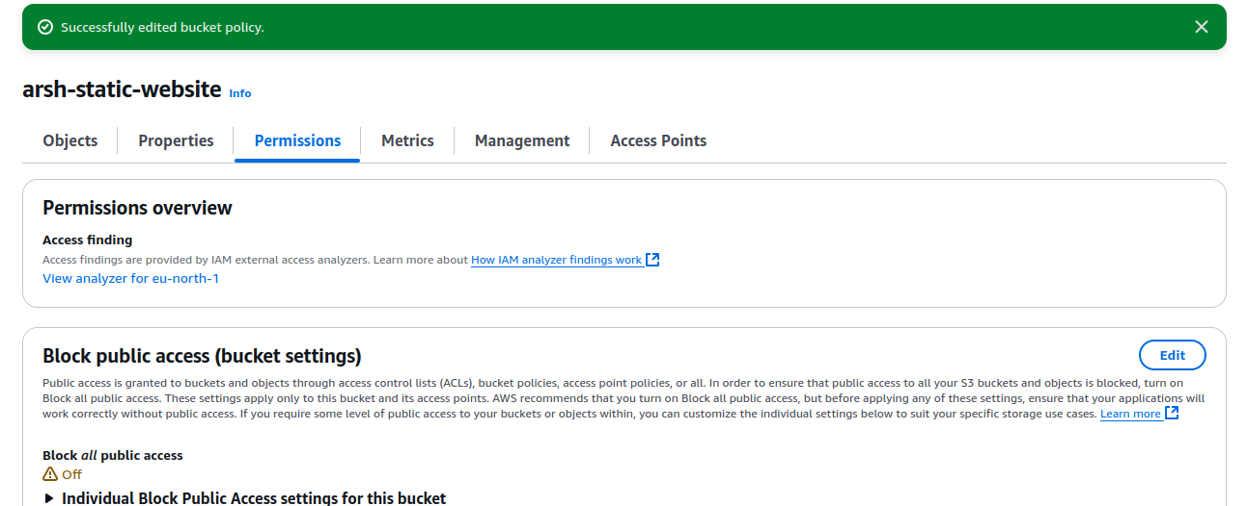

Replacing your bucket name with “ arsh-static website”.

### **Enabling Static Website Hosting**

1. **Going to the Properties**
   * Navigate to the Properties tab of your bucket.
2. **Static Website Hosting**
   * Scroll down to "Static website hosting" and click Edit.
   * Select Enable.
   * In the Index document field, enter index.html.
   * Saving the changes.

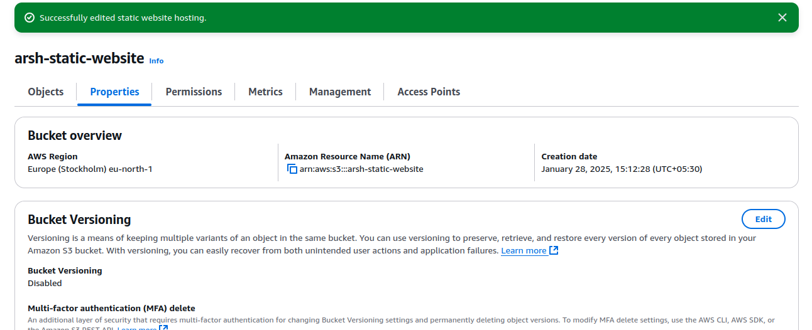

Enables successfully.

**Accessing the website**The website can be accessed via URl we can get it in properties section .

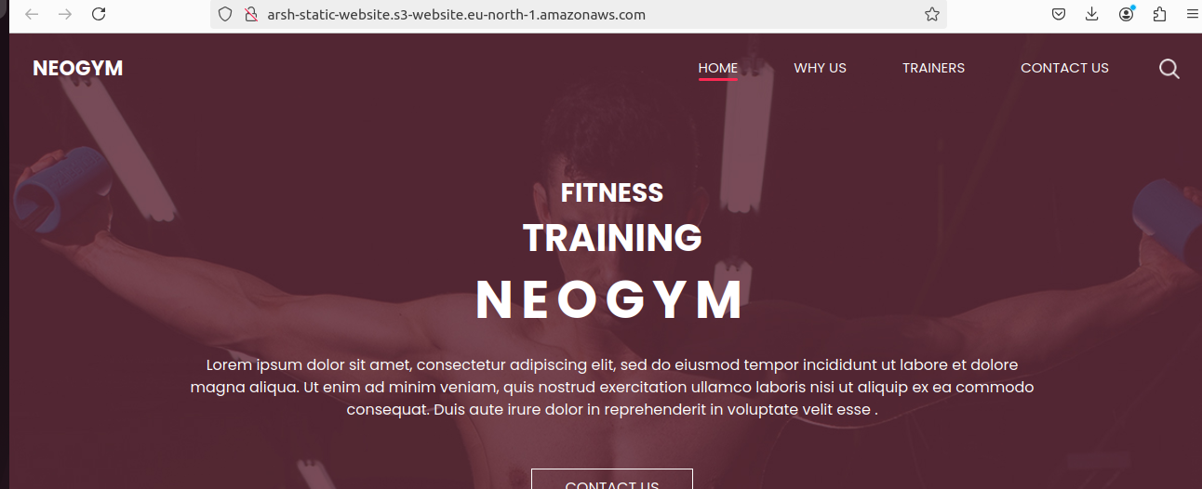

Here is the website starting with my name i.e. arsh-static-website.

3. Launch an Ubuntu EC2 instance on AWS, with 10GB root volume, and SSH from your local machine using the private key.

-> Launching a new instance.

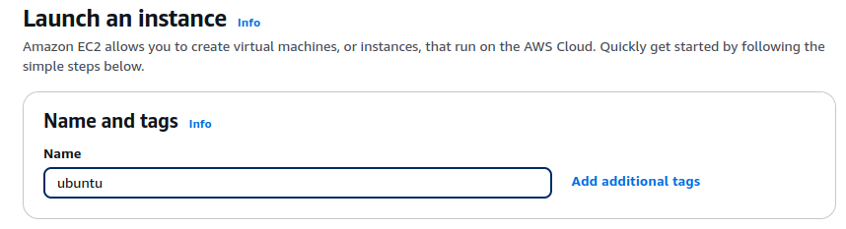

Choosing an AMI (Amazon Machine Image)

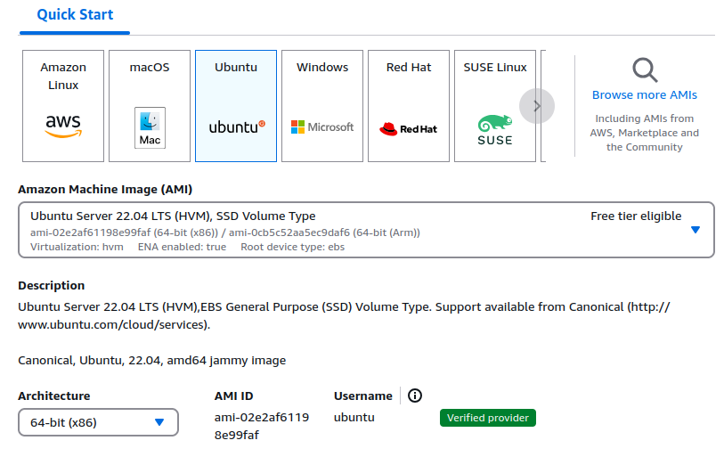

**choosing an Instance Type**

Selecting **t3.micro** (Free Tier Eligible) for basic usage available in eu-north-1b.

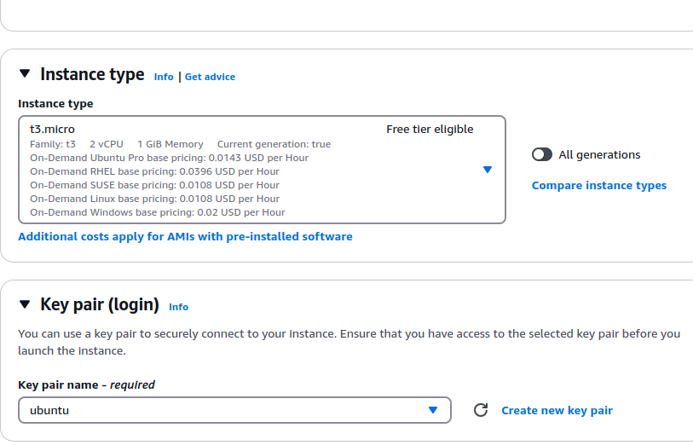



Successfully created an instance.

Here is the summary of the instance.

**Configuring the Storage (Root Volume)**

* Under **"Adding Storage"**, editing the root volume size to 10GB.
* 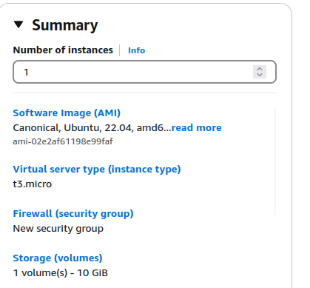

->Now, SSH from my local machine using the private key

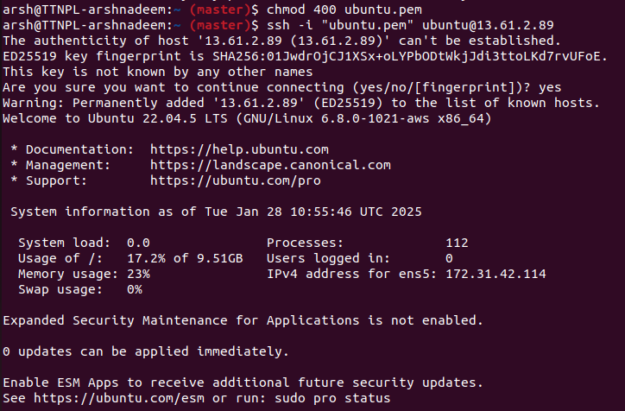

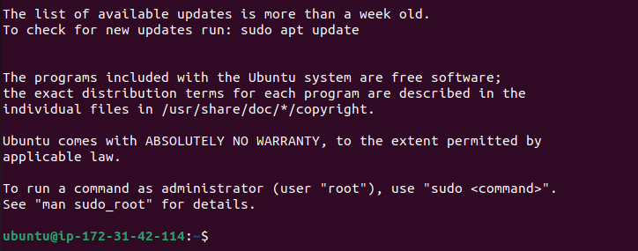

ubuntu@ip-172-31-42-114 indicates that the connection is successfully created.

4. Install nginx package in the above server and access this page from your local browser using a domain name instead of IP address of the server.

-> installing nginx

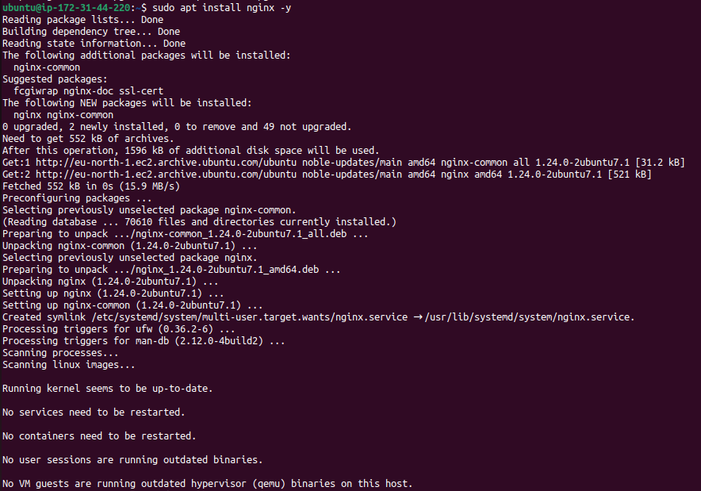

Starting and enabling nginx server

Also verifying if nginx is running or not using Ssh

And checking the status.

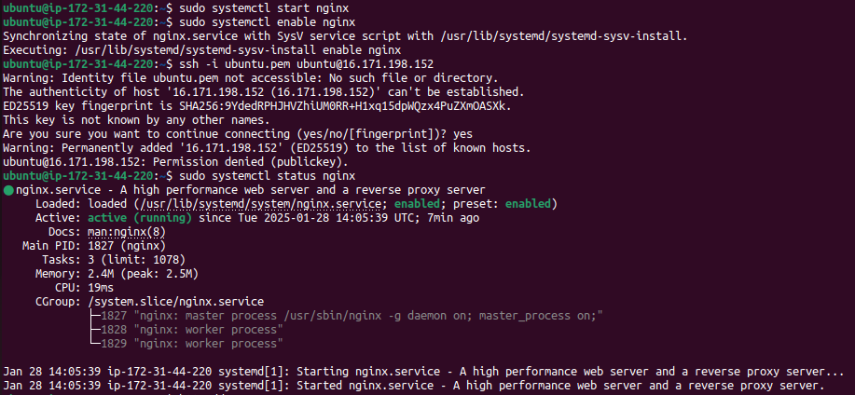

1. List out the types of instance based on the pricing model and write a brief about your understanding about it.

Different use-cases are catered by different types of EC2 instances based on different pricing models offered by AWS.

Let me break down these pricing models with examples:

->On-Demand Instances

What it is: Purchase compute capacity according to the hour or second with zero long-term commitments.

Use Case: Ideal workloads with short-term and unpredictable workload or are used in testing and development.

Example: You spin an instance to process a couple files, then shut it down when it is done. You just pay for the time that it is running.

->Reserved Instances

What it is: Promise to use an instance for 1 or 3 years in return for a heavy discount.

Use Case: Good for workloads with predictable, steady usage (e.g., a production database).

->Spot Instances

What it is: Buy unused EC2 capacity for a lower price (up to 90% off), but can be interrupted by AWS if necessary.

Use Case: Ideal for flexible workloads, batch processing, or jobs that can handle interruptions. For example machine learning models or data analysis where interruptions cannot make severe damages.

->Savings Plans

What it is: A flexible pricing model that enables discounts if you are committed to using a certain amount of compute power for 1 or 3 years.

Usage: Comprehensible for predictable workloads, flexibility is offered across instance families and regions For instance, You decide to spend $100/month on compute power but may change instance types (ex: t2. micro to m5. large).

->Dedicated Hosts

What it is: Physical servers that are for you to use, often required for compliance or specific licensing. Use case: Suitable for organizations that require complete control of the hardware. Use software that requires server licensing tied to physical hardware, e.g. Oracle.

->Dedicated Instances

What it is: Instances that run on hardware dedicated to a single customer, which means you will not share the physical hardware with others.

Use Case: Provides improved isolation for sensitive workloads without using up an entire server. Such examples might include a company housing sensitive financial information and opting for Dedicated Instances for increased isolation. Capacity Reservations